David Hendricks

Brother Dudley

CS165

July 5, 2019

Asteroids / uiInterface Keypress Debugging

CS165 Asteroids uses the up arrow for ship thrust, left arrow to rotate ship left, and right arrow to rotate ship right. That all works fine. However, e acts as up arrow key down, but the corresponding key up is never received. Therefore, the ship keeps thrusting as long as the student-provided logic allows (mine has a “speed limit”). Similarly, d keeps the ship rotating to left, and e continually rotates ship right. Pressing e followed by d makes the ship move in corkscrews.

Debugging depends on the stakes – for a quick assignment, one could perhaps diagnose the underlying issue at a basic level, and write a workaround. If this had major stakes, like a government or defense department contract or even a proposed version update on published software, much peer review and testing would be needed to determine the “root cause” of the issue, repair options, and test any fix for possible side effects.

I will ask the instructor and the class to help know the scope of the problem. I’m working in the VM / ubuntu linux environment. I see conditional compilation in uiInteract.h. Do those in a Windows or Apple environment see the issue with keys d, e, f? If not, any fix should be specific to Linux.

Steps to isolate the cause:

1. Add #include <iostream> in uiInteract.cpp.
2. Add debug code to uiInteract.cpp as follows:

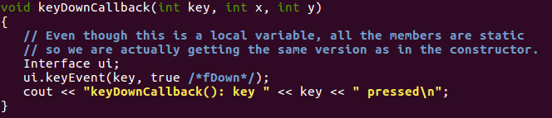

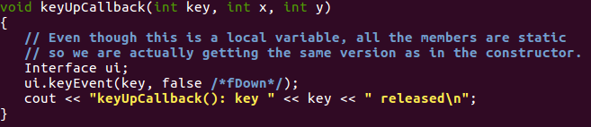

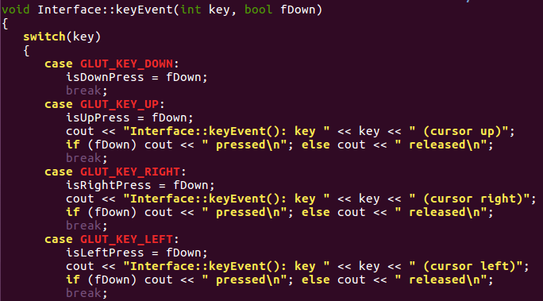

After compiling and running, push and release up arrow, left arrow, right arrow in sequence and quit.

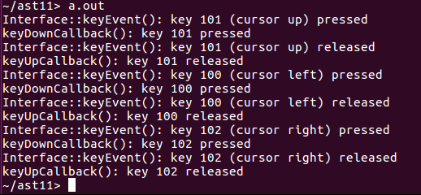

Now, to see the issue, here’s e, d, f in sequence:

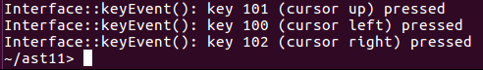

It’s picking up the key press in each case but not key release.

After adding similar debugs in Game, here’s the effect of e to Asteroids:

